 |  |  |  |  |  | Base
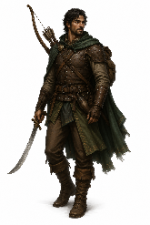 | 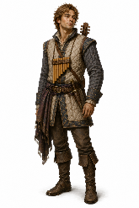 |  |  |  |  | Upside down image
 |  |  |  |  |  | Rightside up image
Ranger | Bard |  |  |  |  | B
 |  |  |  |  |  | Base
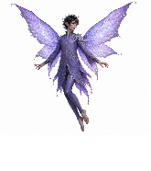 |  |  | 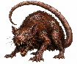 |  |  | Upside down image
 |  |  |  |  |  | Rightside up image
Fairy | Fairy | Fairy | Giant Rat | Giant Rat | Giant Rat | B
Top row: 35mm=7ft ; bottom row: 25mm=5ft A5 TTRPG 25mm figurines template - aoakley.com public domain 2026-07

